# **GEOMETRIC INTUITION OF**

# **LOGISTIC REGRESSION**



≤

**What is Logistic Regression:**

It is the multi-class classification technique used in Machine Learning to predict the class label i.e ,s where belong to some class but not a real value.

**Let,s understand it geometrically:**

**ASSUMPTION** : The biggest assumption before solving it is our data is linearly separable or almost linearly separable.

→> Let we have two classes of points i.e positive and negative.

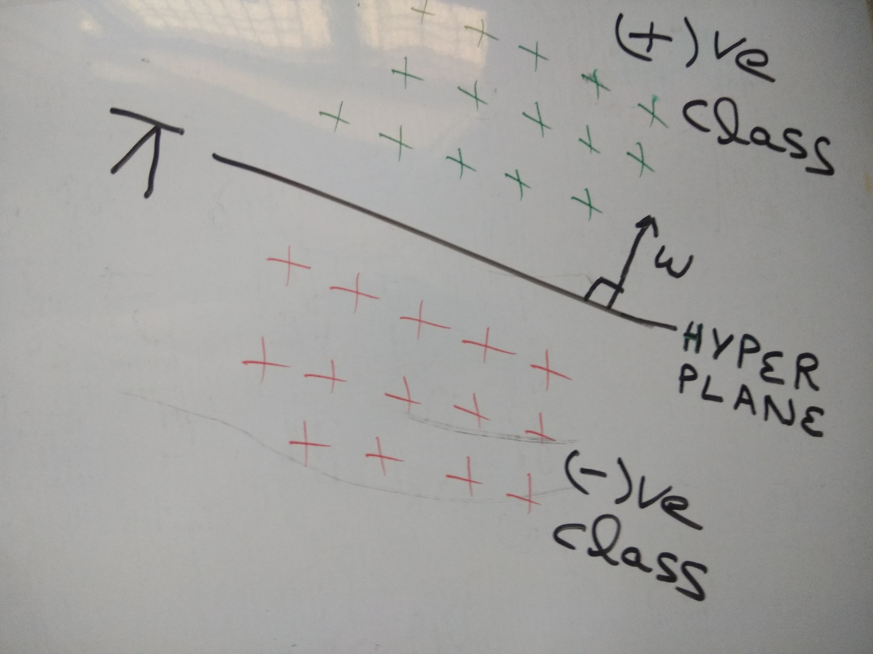

In above picture we have:

**W** Normal to plane, Pi() Plane

So the equation of plane will be :

=0

If we pass through origin :

=0

and**b**is scalar

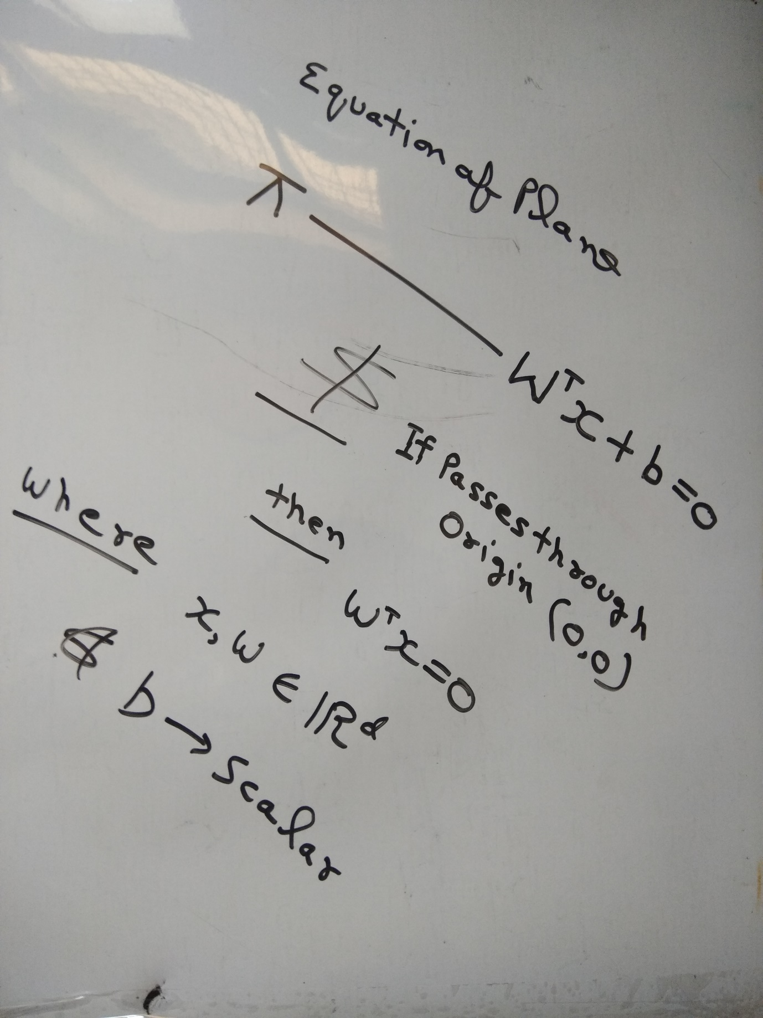

So now we have are given DATASET **Dn** having positive and negative points

**TASK IN LOGISTIC REGRESSION IS :**

To find **W** and **b** to discover a plane such that it separates positive and negative point i.e we have to find (**^**).

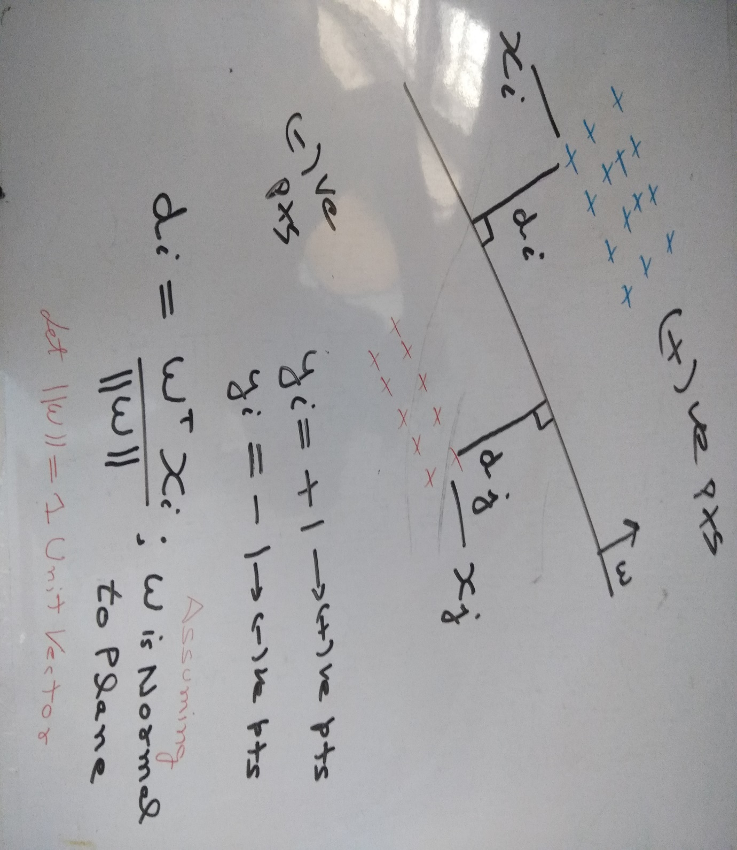

Here, in above image we can find out the distance from any point to plane Pi(^).

Also we assumed W is a unit vector and normal to plane.

So now comes to interesting part via seeing diagram in above picture i.e if we calculate:

1> Distance from positive point to plane **(^)** it will be positive .

i.e **di=> 0** because (**W** and  are on same side).

2> Distance from negative point to plane **(^)**it will be negative.

i.e dj= **< 0** because (**W** andare on opposite side).

**NOW THE LOGICAL PART COMES:**

So our classifier says →>

if (**)>0**then**yi=+1**

if(**)<0**then**yi=-1**

Now lets take different cases:

**case1: For positive points**

let **Pi()**passes through origin

if is positive i.e (+1) and (**)>0**our classifier saying

**Now** if **>0**and**Yi**is positive

then**W** is correctly classifying the positive point.

**case2: For negative points**

let **Pi(**passes through origin

if **Yi** is negaitive i.e (-1) and  **<0**our classifier saying

**Now** if (**\*** **)>0**and**Yi**is negative

because (-)*(-)=(+)

then**W** is correctly classifying the negative points.

**OBSERVATION** from above logical part is:

for both positive and negative points

if (**\*** **)>0 then L.R model is correctly classifying the points Xi,s**

NOW in the same fashion for negative points:

**case3:**

If Yi is positive i.e (+1) and **)<0**

then **L.R** is saying it is negative class

then (**\*** **)<0 i.e miss classified point.**

**case4:**

If Yi is negative i.e (-1 )and **W(transpose) xi)>0**

then **L.R** is saying it is positive class

then **\*** **) < 0 i.e miss classified point.**

**OBSERVATION** from above logical part is:

for both positive and negative points

if (**\*** **)** **)<0 then L.R model is incorrectly classifying the points ,s.**

At the end of the day we want our classifier V.good i.e minimize the no. of miss classification or maximize the no. of correctly classified point.

i.e we want as many points possible to have (**\*** **)** **)>0**

**i.e arg max(w)** ()**:( \*** **)**

here in above equation  and are fixed comes from **(Dtrain)**

now we have to compute**W**variable here

SO our optimization problem here is to find W* (optimal w) to maximize:

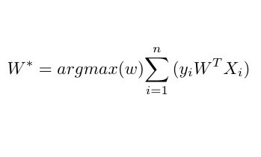

Now by understanding function we have (**\*** **)** is signed distance.

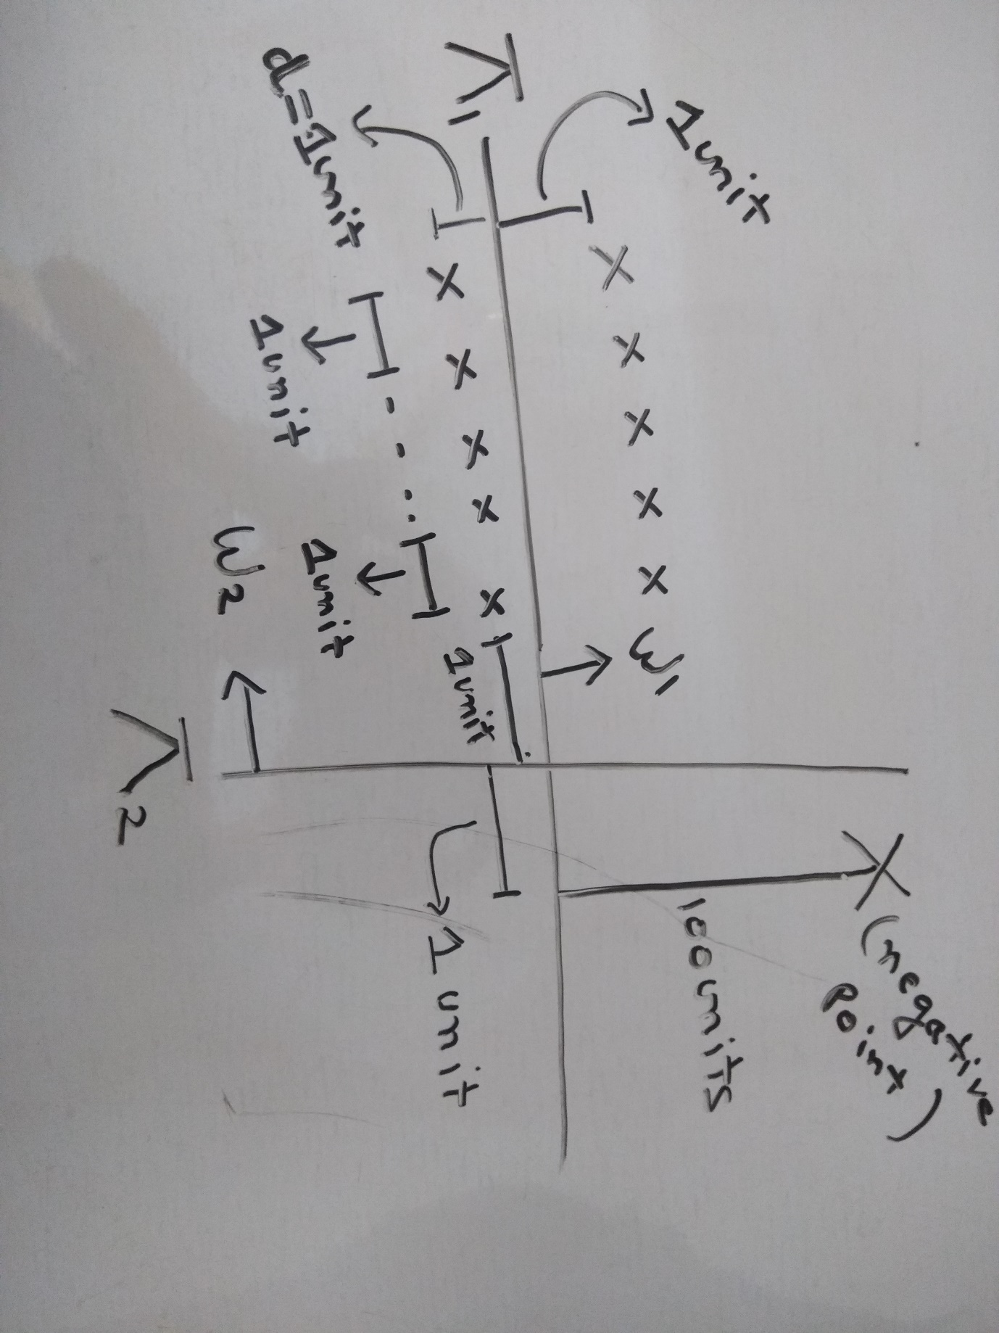Now let,s assume by looking below image:

BY OBSERVING FROM ABOVE IMAGE:

let we have 10 points equal distance from plane Pi-one() and X 100 unit distance from plane Pi-one():

CASE 1:

Now if we choose W1 and Pi-one() as our separator

then ():(**\*** **)=5+5–100=-90**

here we are trying to maximize the signed distance.

CASE 2:Now if we choose W2 and Pi-two() as our separator

then ():(**\*** **)=1+2+3+4+5-1-2-3-4–5+1=1**

Now as per our objective we will choose **Pi-two()** as our classifier.

But if we think intuitively **Pi-two()** is terrible classifier i.e only one point is correctly classified.

Now

Accuracy of **Pi-one()**=(10/11)

and

Accuracy of **Pi-two()**=(6/11)

here the accuracy to maximum sum of signed distance **Pi-two()** is better then **Pi-one()** as a classifier.

This is happening because of extreme point which is 100 units distance from **Pi-one()**in the direction of **W1.**

i.e single extreme/outlier point is changing our model.

So max-sum of signed distance can be impacted by outlier.

Now we have to modify  **W*=argmax(w)**():(**\*** **)** byTechnique called**Squshing.**

**SQUASHING →**

So instead of using simple signed- distance we will use :

If signed- distance is small: Use as it is.

If signed- distance is large: Make it a small value.

So we want a function :

When its value is small : increasing linearly.

When its value becomes large : Tapper it off.

Now, One such function we have is **SIGMOID FUNCTION**

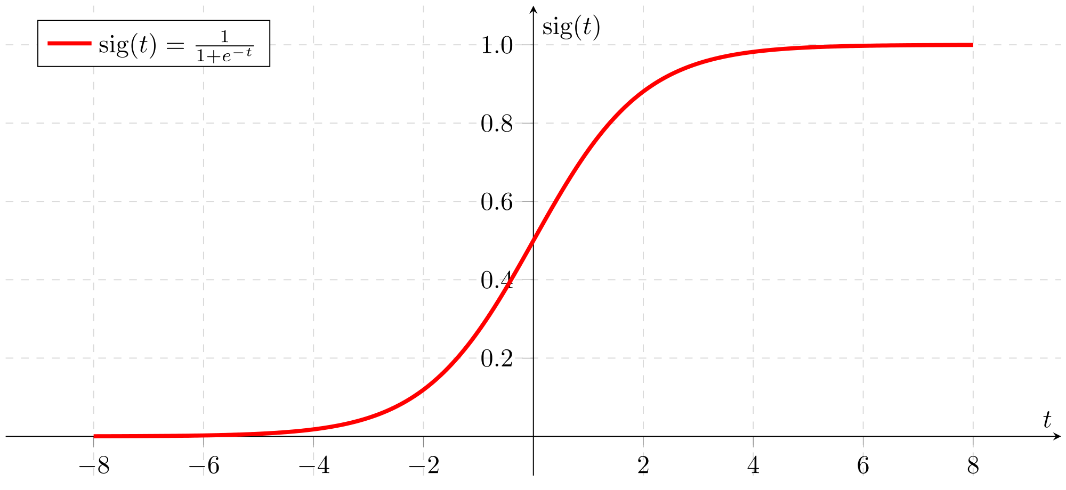

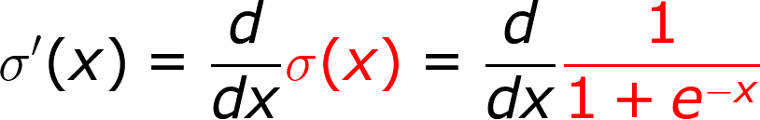

Now if we apply sigmoid function to our W* we will have:

W*= **(argmax(w) (): ) )**

So this above function will be less impacted by outlier.

Now we know the property of monotonic function:

If x increases then G(x) increases and

If x1>x2 then G(x1)>G(x2)

Now if G(x ) is monotonic then

1>argmin F(x)=argmin G(F(x))

2>argmaxF(x)=argmax G(F(x))

NOW — -> We know that log is monotonic function

and log(1/x)=-log(x)

Now if we imply log on W* then W* will be:

**W*=(arg max(w) (): log() ))))**

**W*=(arg max(w) (): -log( ))))**

**W*=(arg min(w) (): log(…….equation 1**

Now if there will be no 1 in the above equation then:

**W* = (argmin(w) (): log(**

W* **= (argmin(w) ():**

W* **= (argmin(w) (): …….equation 2**

**i.e SUM of signed distances**

So in optimization problem of Logistic Regression with a small change using exp and log we have sum of signed distance which have huge problem of outlier so that,s why we will not use **…(equation 2) for optimization problem.**

**Other formulation of W* using probabilistic method is as follows:**

**W*=argmin(w)(): σ -{Yi*log(P(i))+(1-Yi)*log(1-P(i))}**

if we correlate this equation with**……(equation 1)**

**then P(i) — -> σ ().**

so from **……(equation 1)**we get**W* optimal W**

is also called **Weight Vector i.e**

W belong to =<w1,w2,w3……..wd>

d=no of features/dimentions.

In L.R we have weight associated with every featuresIf is positive ,

Xqi high * will high (i:1 to d (*)) will high **then**

**(**Wi\***) also high i.e P(=Positive) will high.**

In similar fashion :

If Wi is nagative ,

high Wi* will low (i:1 to d (Wi*)) will low **then**

**(**Wi\***) also low i.e P(=Positive) will low**

**P(=Negative) will high.**